Verification of PI3USB30532 IBIS model
- Introduction:
To verify the correlation between the ibis model and hspice model, we need to do some simulations:
- SWITCH1:
- The frequency of signal is 500MHz:
vin1 dp0n 0 pulse ( 1.0 0 0 .1n .1n 0.9n 2n)
vin2 dp0p 0 pulse ( 0 1.0 0 .1n .1n 0.9n 2n)
- Add 50Ω pull-down resistor and without pull-down capacitance to the output;
- Add 50Ω pull-down resistor and 10pF pull-down capacitance to the output;
- The frequency of signal is 2.50GHz:
vin1 dp0n 0 pulse ( 1.0 0.0 0 20p 20p 180p 400p )
vin2 dp0p 0 pulse ( 0.0 1.0 0 20p 20p 180p 400p )
- Add 50Ω pull-down resistor and without pull-down capacitance to the output;
- Add 50Ω pull-down resistor and 10pF pull-down capacitance to the output;

- SWITCH2:
- The frequency of signal is 500MHz:
vin1 auxp 0 pulse ( 1.0 0 0 .1n .1n 0.9n 2n)
vin2 auxn 0 pulse ( 0 1.0 0 .1n .1n 0.9n 2n)
- Add 50Ω pull-down resistor and without pull-down capacitance to the output;
- Add 50Ω pull-down resistor and 10pF pull-down capacitance to the output;
- The frequency of signal is 2.50GHz:
vin1 auxp 0 pulse ( 1.0 0.0 0 20p 20p 180p 400p )
vin2 auxn 0 pulse ( 0.0 1.0 0 20p 20p 180p 400p )
- Add 50Ω pull-down resistor and without pull-down capacitance to the output;
- Add 50Ω pull-down resistor and 10pF pull-down capacitance to the output;

- Conclusion:
- For SWITCH1 and SWITCH2, the simulation results of IBIS model can match quite well with the HSPICE model at most of the different load conditions.

- Simulation Result:
- SWITCH1:
PI3USB30532
OUT0

SCL_C
SDA_C
OUT1

SCL_C
SDA_C
R

SCL_C
SDA_C
R

SCL_C
SDA_C
DP0P

SCL_C
SDA_C
C

SCL_C
SDA_C
C

SCL_C
SDA_C
Differential Signals

SCL_C
SDA_C
Output

SCL_C
SDA_C
DP0N

SCL_C
SDA_C
······

·
·
·

······

·
·
·

RX2P

SCL_C
SDA_C
RX2N

SCL_C
SDA_C
IN0

SCL_C
SDA_C
IN1

SCL_C
SDA_C
- The frequency of signal is 500MHz:
- Add 50Ω pull-down resistor and without pull-down capacitance to the output;
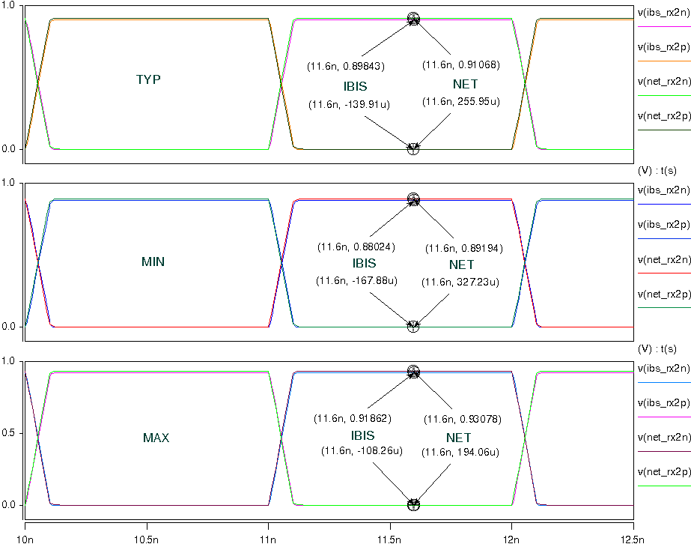
- Add 50Ω pull-down resistor and 10pF pull-down capacitance to the output;
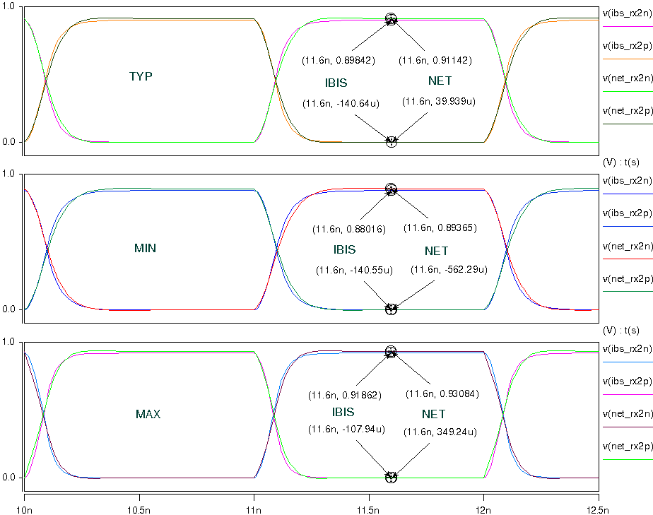
- The frequency of signal is 2.50GHz:
- Add 50Ω pull-down resistor and without pull-down capacitance to the output;
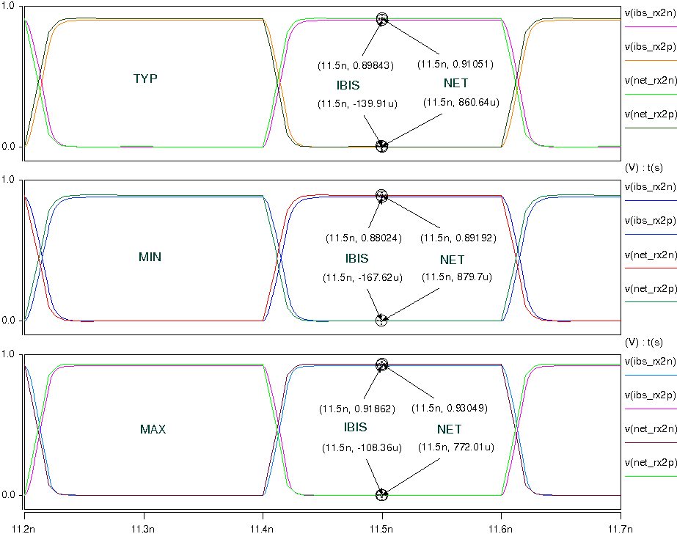
- Add 50Ω pull-down resistor and 10pF pull-down capacitance to the output;
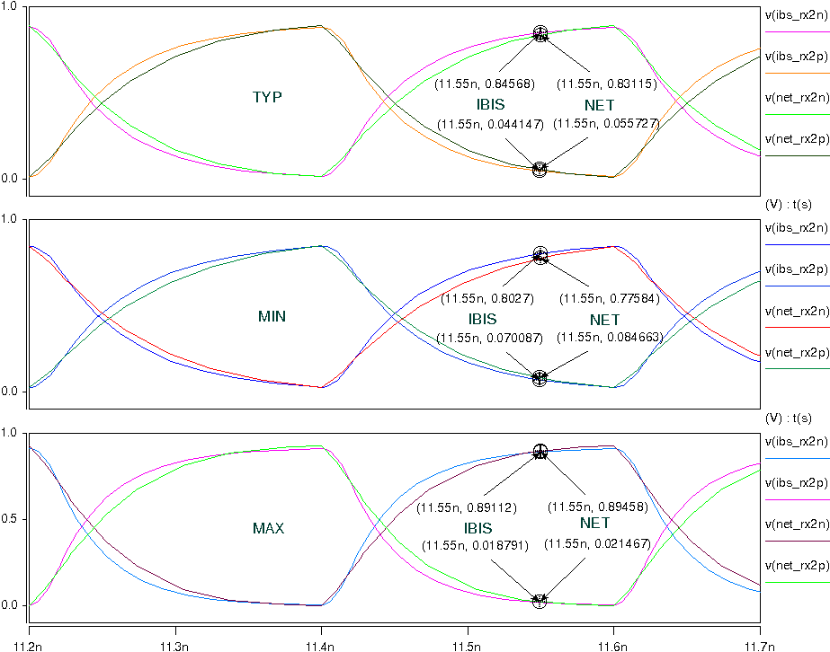
- SWITCH2:
PI3USB30532
OUT0

SCL_C
SDA_C
OUT1

SCL_C
SDA_C
R

SCL_C
SDA_C
R

SCL_C
SDA_C
AUXP

SCL_C
SDA_C
C

SCL_C
SDA_C
C

SCL_C
SDA_C
Differential Signals

SCL_C
SDA_C
Output

SCL_C
SDA_C
AUXN

SCL_C
SDA_C
······

·
·
·

······

·
·
·

SBU1

SCL_C
SDA_C
SBU2

SCL_C
SDA_C
IN0

SCL_C
SDA_C
IN1

SCL_C
SDA_C
- The frequency of signal is 500MHz:
- Add 50Ω pull-down resistor and without pull-down capacitance to the output;
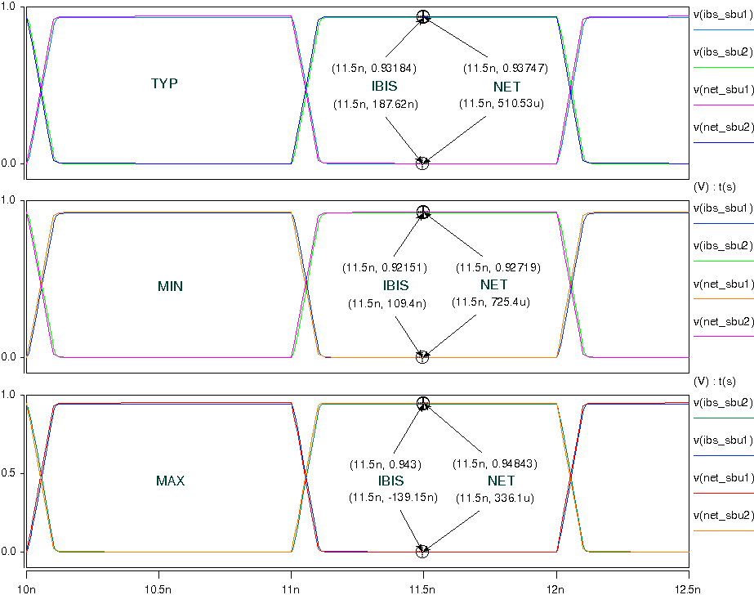
- Add 50Ω pull-down resistor and 10pF pull-down capacitance to the output;
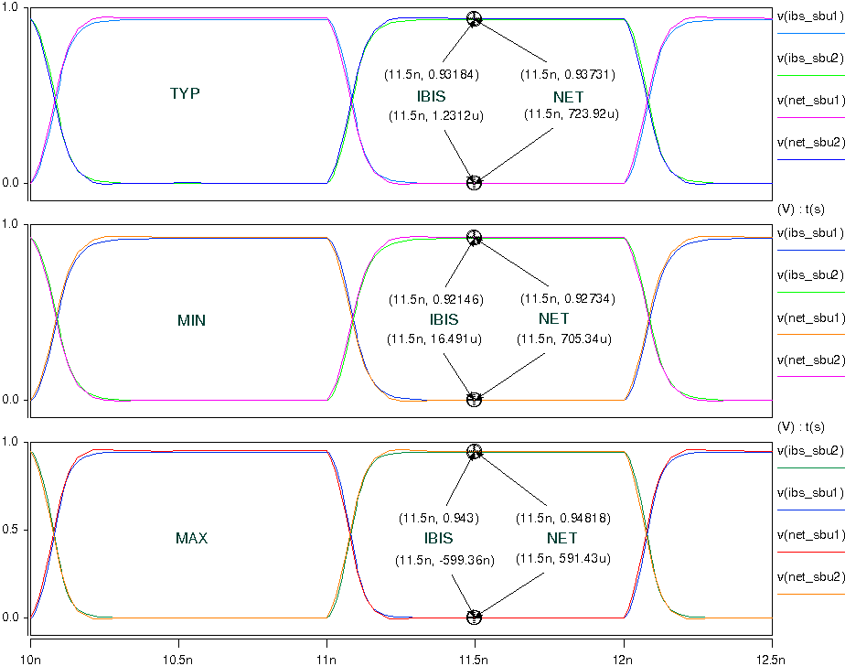
- The frequency of signal is 2.50GHz:
- Add 50Ω pull-down resistor and without pull-down capacitance to the output;
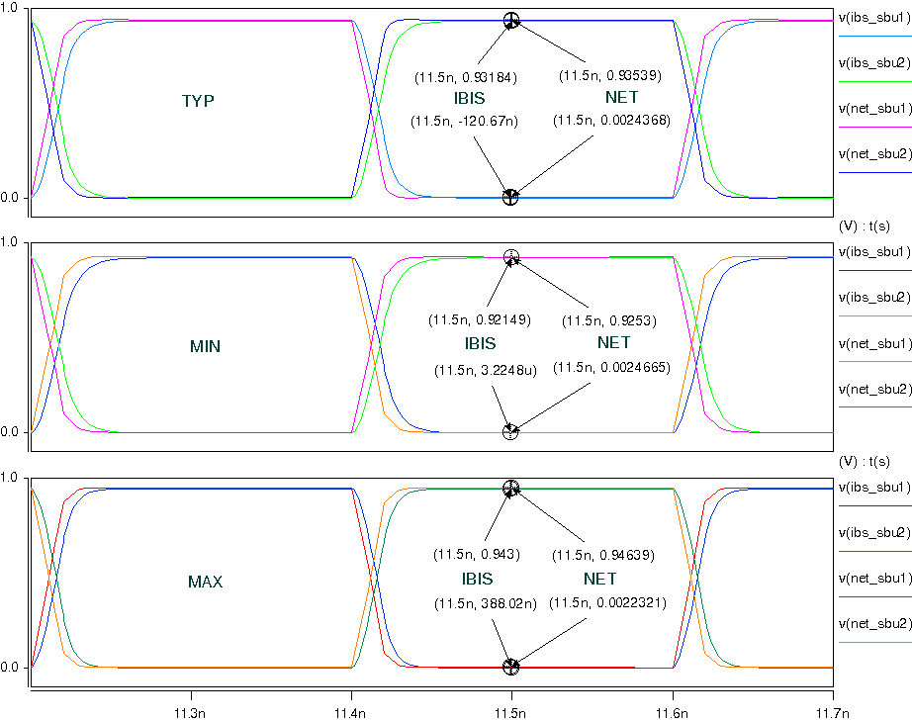
- Add 50Ω pull-down resistor and 10pF pull-down capacitance to the output;
